

Gynecologic cancer prevention and screening

Pilot uterine cervical cancer screening with self-sample

**Coll Uterí Cancer Screening Technical Office**

Semiannual activity report for the six-month period from January - June 2023

**Legal notice**

Total or partial reproduction - computer processing, transmission in any form or by any means, whether electronic, mechanical, photocopying, recording or otherwise - in scientific and medical publications is authorized provided that the authors and the Institut Català d'Oncologia are expressly cited, and their logo is appropriately displayed.

#### Recommended citation of this document:

*Technical Office for Cervical Cancer Prevention, Cancer Epidemiology Research Program Catalan Institute of Oncology. Memòria d'activitat semestral gener - juny 2023 - Pilot de cribratge de càncer de coll uterí amb automostra, 2023.*

*In this document, the authors respectfully acknowledge that not all people with uterine cervix identify themselves as women. Throughout the Protocol, the term "women" is used to refer to both women and other people with uterine cervix.*

WORK TEAM

#### Technical Office for Cancer Prevention in Coll Uterí Cancer Epidemiology Research Program

**Cap d'Unitat**: Laia Bruni*.

**Specialist physician, coordination of the Technical Office of Cribratge**: Paula Peremiquel*.

**Quality Control and Data**: Claudia Robles.

**HPV protocol and screening technologies**: Raquel Ibáñez*.

**Support: Statistician**: Esther Roura*, Laura Monfil, Xisca Morey; **Computer**: David Gómez**;**

**Scientific-technical**: Valentina Rangel; **Administrative**: Maite Carvajal.

*The implementation of the Office and the maintenance of its activity in the South Metropolitan Health Region is carried out in coordination with different managers and professionals from the following institutions and services:*

* ***CatSalut:***
  + ***Regió Sanitària Metropolitana Sud****: Daniel Fernández, Maria Blanca Muntané, Jordi Peláez, Mª Eugènia Rey, Xavier Sintes, Lourdes Tamarit.*
  + ***Gerència del Medicament****: Amparo Castellà, Eduard Cavero, Núria Escoda, Andrea Molina.*
  + ***Integrated Health Processes Management, Operational Planning and Evaluation Management****: Ramon Escuriet, Assumpta Ricart.*
  + ***Divisió de Desplegament Territorial, Gerència d'Organitzacions****: David Frigola, Sandra Martínez.*
* ***Col-legi Oficial de Farmacèutics de Barcelona:*** *Guillermo de Bagaria, Ariadna Cervià, Maria Estrada, Cristina Rodríguez.*
* ***Consell de Col-legis de Farmacèutics de Catalunya****: Fernando Espí.*
* ***Departament de Salut, Communication:*** *Marta Berdejo, Marcos Freijo, David Ortega, Montserrat Ramírez.*
* ***Catalan Institute of Oncology****:*
  + ***Computer Services****: Marta Carbonell, Francesc Garcia, Juan Pedro Rivas.*
  + ***Cancer Prevention and Control Program****: Carmen Vidal.*
* ***Catalan Institute of Health:***
  + ***ASSIR of El Prat de Llobregat and ASSIR of Gavà****: Marta Díaz, Clara Grau, Lídia Martínez, Silvina Roca, Blas Rupérez, Lídia Santos, Núria Tosquella.*
    - ***ASSIR de Catalunya, Direcció Assistencial d'Atenció Primària i a la Comunitat****: Cristina Martínez, Encarna López.*
    - ***Information Systems, Gerència Territorial Metropolitana Sud****: Arturo García, Sònia Hernández, Nacho Nieto.*
  + ***University Hospital of Bellvitge:***
* ***Servei d'Anatomia Patològica****: Núria Baixeras, Lara Pijuan.*
* ***Gynecology Department****: Maria Eulàlia Fernández.*
* ***Computer services****: Sònia Hernández.*
* ***Hospital de Viladecans: Servei de Ginecologia****: Glòria Tena.*
* ***Pla Director d'Oncologia****: Josep Alfons Espinàs, Rebeca Font.*

*Consortium of Biomedical Research Network - Epidemiology - CIBERESP

EXECUTIVE SUMMARY

Semiannual activity from January to June 2023 of the cervical cancer screening pilot with self-sampling of the Early Detection of Cervical Cancer Program at ASSIR Prat and ASSIR Gavà:

|  |  |  |  |  |
| --- | --- | --- | --- | --- |
|  | **Eligible persons and invitations to participate in the screening with automostat** | **Women who accept self-sample screening** (will pick up device) | **Women who participate in the screening with self-sampling** (return the sample) | **Women with positive HPV test result** |
| **ASSIR Prat** | 474 | 83% | 80% | 13.6% |
| **ASSIR Gavà* ASSIR Gavà** | 1267 | 78% | 74% | 14.1% |
| **Total** | **1741** | **79%** | **76%** | **14.0%** |

*\* Includes the municipalities of Begues, Botigues de Sitges, Castelldefels, Gavà, Sant Climent de Llobregat and Viladecans.*

The ICO Hospitalet's Càncer de Coll Uterí Technical Screening Office (OTC) is the first one in Catalonia and its objective:

1. To serve as a model for the future extension of the new Organized Program for the Early Detection of Cervical Cancer (PDPCCU) to the whole Catalan territory under the guidelines of the Oncology Master Plan (PDO).
2. To develop all the necessary technical structure to deploy the new PDPCCU in the area of assistance referral including:
   1. Design and establishment of new assistance circuits.
   2. To carry out the OTC's own assistance activities (management of invitations, exhibitions and customer service).
   3. Functional support to the PDO and ICO computer services in the development of the Technical Office program and integrations with the rest of the information systems of the integrated public health system of Catalonia (SISCAT).
   4. Evaluation and quality control of the OTC and the PDPCCU.
   5. Adaptation of clinical protocols.
   6. Development of the training plan and implementation of the training plan for the professionals involved.
   7. Implementation studies for the improvement and optimization of the circuits. Generation of knowledge for informed decision making at PDO and CatSalut level.
   8. Communication activities to municipalities and citizens.
3. The OTC's own activity is in synergy with all the scientific and technical support activity that the Cancer Epidemiology Research Program (PREC) provides to the PDO in the development and deployment of the new PDPCCU throughout Catalonia, beyond the OTC, which includes:
   1. Scientific update and support for informed decision making in HPV prevention.
   2. Estudis of costs, requirements assistance requirements i elaboration of budgets.
   3. Technical support for the drafting of tender documents.
   4. Scientific leadership and coordination of the new HPV protocol with the development of clinical management algorithms.
   5. Design and planning of strategies for the deployment of the PDPCCU throughout Catalonia.
   6. Evaluation of the new HPV protocol in Catalonia and its impact.
   7. Evaluation and operation of the information systems to provide management information to the PDO and the different CatSalut departments involved.
   8. Design and development of training plan contents for the professionals involved.
   9. Support in the development of the communication plan.
   10. Implementation support.

In this document we detail the activity carried out at the OTC during the first half of 2023, from January to June.

Document index

Definitions and acronyms 7

1/ BACKGROUND 8

2/ SUMMARY OF THE ASSISTANCE ACTIVITY 9

Referrals from ASSIR and confirmation of eligibility by self-sampling 9

Acceptance and participation 11

Reasons for non-acceptance 14

Non-participation 15

Activity in the OF and pharmaceutical distributors. 15

Laboratory activity 17

HPV test results and follow-up. 18

3/ COORDINATION AND FOLLOW-UP ACTIVITIES WITH ALL THE AGENTS INVOLVED. 20

Annexes 21

Annex 1. Pharmacy offices participating in the pilot. 21

## Definitions and acronyms

**Definitions**:

* **Women convalescents**: eligible women who are invited to the screening with self-sampling via SMS.
* **Women who accept to participate**: convivial women who collect the material for the automostra at the pharmacy.
* **Women who participate**: convivial women who collect the material for the automostra and return the sample to the pharmacy.
* **Non-participating women without acceptance**: convalescent women who do not collect the material for the self-sample at the pharmacy.
* **Non-participating women with acceptance**: convalescent women who collect the material for the self-sample at the pharmacy but do not return the sample.

**Acronyms**:

* AGC: *atypical* glandular *cells* of undetermined significance (*atypical glandular cells*).
* AIS: Adenocarcinoma *in situ*.
* ASC-H: Atypical squamous cell carcinomas in which high grade lesion cannot be ruled out.
* ASC-US: Cèl-lules escatoses atípiques de significat indeterminat (*atypical squamous cells of undetermined significance*).
* ASSIR: Attention to Sexual and Reproductive Health.
* CCU: Cancer of Coll Uteri.
* COFB: Official College of Pharmacists of Barcelona.
* ICO: Catalan Institute of Oncology.
* IQR: Rang Interquartílic.
* HSIL: *High-grade squamous intraepithelial lesion* (*high-grade squamous intraepithelial lesion*).
* LSIL: *Low-grade squamous intraepithelial lesion (*lesió intraepitelial escatosa de baix grau).
* OF: Oficina de Farmàcia.
* OTC: Oficina Tècnica de Cribratge.
* PDPCCU: Programa de Detecció Precoç de Càncer de Coll Uterí.

-P25-75 : Percentile 25-75.

* PLAENSA: CatSalut Satisfaction Survey Plan.
* SAP: Primary Health Care Services.
* SISAP: Sistemes d'Informació dels Serveis d'Atenció Primària.
* SMS: *Short Message Service* - system for sending messages between mobile phones.
* HPV: Human Papillomavirus.

# 1/ BACKGROUND

In Catalonia, in parallel to the implementation process of the HPV screening test initiated in 2019, in June 2021, a pilot program for women between 30 and 65 years of age will begin in SAP Delta, in the Southern Metropolitan Area (province of Barcelona), to implement the use of the self-sample as a sample collection method for screening.

The model established with the pilot program initiated in SAP Delta in 2021 is the one that is intended to be implemented in the rest of Catalonia as a population-based screening program progressively over the next few years.

In this context, and with a view to the future implementation of the CCU population-based screening program, the first Technical Screening Technical Office (OTC) for cervical cancer in Catalonia was created. The OTC allows to facilitate the logistics of the invitations and the follow-up of the women in case of a positive screening result.

A total of 72 OFs participate in this pilot, 92% of the OFs existing in the territory. Specifically, the participation per municipality is as follows (Annex 1):

-Begues : 2/2,100%.

* Les Botigues de Sitges: 1/1, 100%.
* Castelldefels: 13/15, 86.6%.

-Gavà : 15/16, 93.8%.

* El Prat de Llobregat: 22/25, 88%.
* Sant Climent de Llobregat: 1/1, 100%.

-Viladecans : 18/18, 100%.

# 2/ SUMMARY OF THE ASSISTANCE ACTIVITY

This report includes the assistance activity between 01/01/2023 and 30/06/2023. For the indicators of acceptance, participation and positivity, it includes women referred until 30/06/2023 and is followed up until 31/08/2023.

### Referrals from the ASSIR and confirmation of eligibility by self-sampling.

Between January and June 2023, a total of 1,954 women sought early detection of cervical cancer, 501 at ASSIR El Prat de Llobregat and 1,453 at ASSIR Gavà. Of these, 1,741 women (89%) (N=474, 95%, at ASSIR El Prat and N=1,267, 87%, at ASSIR Gavà) met the eligibility criteria to undergo the automated screening test and, therefore, were invited to the pilot. The average age of women eligible to participate in the pilot was 47 years (interquartile range (IQR): 39-54 years).

The number of women opportunistically referred monthly from the ASSIR to the OTC for cervical cancer screening with autopsy has been variable, decreasing significantly in the holiday periods (Christmas to January, Easter to April), both in the ASSIR El Prat and in the ASSIR Gavà (Figure 1).

|  |
| --- |
| **Figure 1. Opportunistic referrals in the first half of 2023, according to ASSIR.** |
| **1st ASSIR El Prat.**   |

*Since the beginning of the pilot in July 2021, a total of 2,516 women have been opportunistically referred. In the first quarter of 2023, specifically, 501 women have been referred.*

**1b. ASSIR Gavà.**

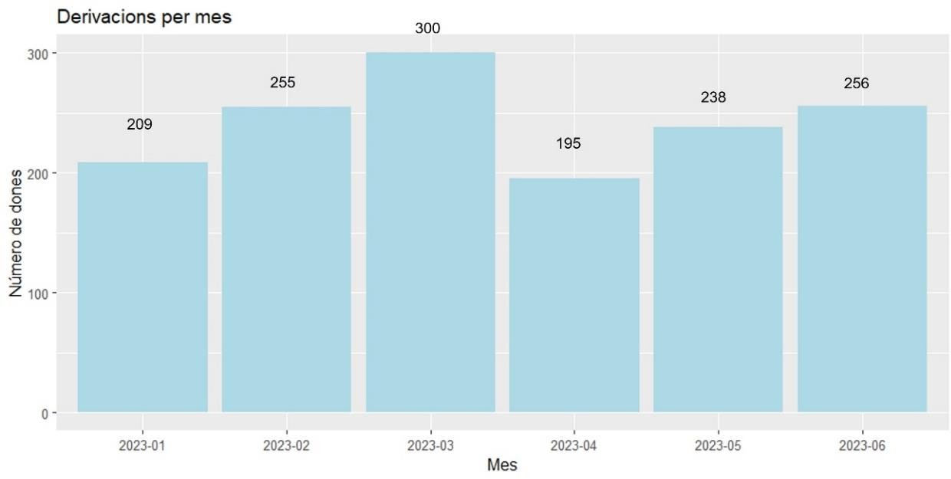

*Since June 2022, when the pilot started at ASSIR Gavà, a total of 2,859 women have been opportunistically referred. In the first quarter of 2023, specifically, 1,453 women have been referred.*

Among the 213 ineligible women (11%) (27 at ASSIR El Prat and 186 at ASSIR Gavà), 154 (72%) had a last test performed in the last 2.5 years, 28 (13%) were being followed up due to an abnormal screening result, 11 (5%) were over 65 years old and required a co-test in order to exit the program, 8 (4%) were under 30 years old, 7 (3%) were not assigned to these ASSIRs territorially, 4 (2%) had been previously hysterectomized, 1 (0.5%) had physical limitations and 1 (0.5%) had a history of heart failure.5%) had physical or psychological limitations to be able to collect the sample (Figure 2). All the women ineligible for the self-sampling screening were first summoned to the ASSIR from the OTC for the corresponding clinical management.

**Figure 2. Reasons for ineligibility.**

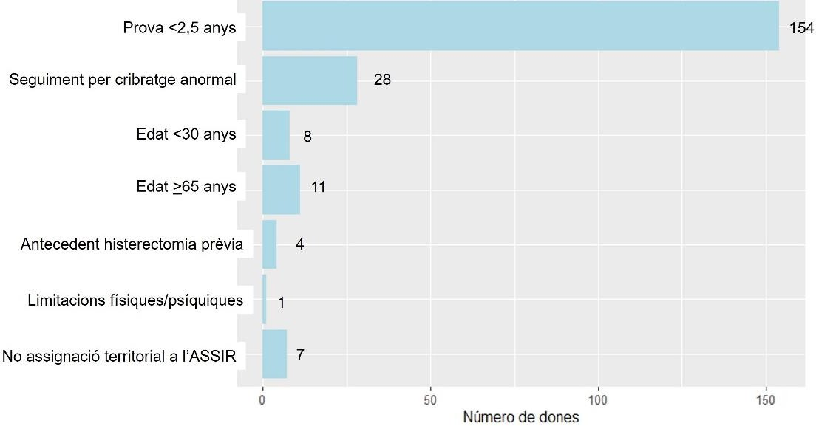

### Acceptance and participation.

A total of 1,381 women (79% of eligible women and convalescents between June 2023) (N=394, 83%, at ASSIR El Prat and N=987, 78% at ASSIR Gavà) have accepted to participate in the pilot with an automobile and have collected the material at the OF, and 1,317 women (76% of eligible women and convalescents between June 2023) (381 (80%) at ASSIR El Prat and 936 (74%) at ASSIR Gavà) have accepted to participate in the pilot with an automobile.317 women (76% of eligible women and convalescents between January-June 2023) (381 (80%) at ASSIR El Prat and 936 (74%) at ASSIR Gavà) have returned the sample to the OF.

Among the municipalities participating in the self-sampling pilot, the highest participation was observed in El Prat de Llobregat (81% of eligible women and convicts), followed by Viladecans (78%), Sant Climent (76%) and Gavà (72%) (Table 1).

**Table 1. Number of women who accept and number of women who participate in the pilot with automostra according to municipality of residence between January and June 2023.**

|  |  |  |
| --- | --- | --- |
| **ASSIR / Municipality** | **Women who accept self-sample screening (will pick up device)**  **N (% )1** | **Women who participate in the screening with self-sampling (return the sample)**  **N (% )1** |
| **ASSIR El Prat de Llobregat** |  |  |
| **El Prat de Llobregat** | 394 (83%) | 381 (81%) |
| **Other** | 0 (0%) | 0 (0%) |
| **ASSIR Gavà** |  |  |
| **Begues** | 35 (81%) | 30 (70%) |
| **Castelldefels** | 311 (74%) | 297 (71%) |
| **Botigues de Sitges** | 11 (79%) | 10 (71%) |
| **Gavà** | 252 (75%) | 242 (72%) |
| **Viladecans** | 346 (83%) | 326 (78%) |
| **Sant Climent** | 19 (76%) | 19 (76%) |
| **Other** | 13 (81%) | 12 (75%) |

*\* Includes women who live in a different municipality from those assigned to the ASSIR El Prat and ASSIR Gavà but who have requested a change of ASSIR of reference.*

*1 Regarding eligible women and convictions.*

##### Time between invitation and acceptance

The time elapsed between the sending of the invitation SMS and the collection of the automostra material at the OF was 9 median days (range: 0-159 days), 7 days (range: 0-128 days) at ASSIR El Prat and 9 days (range: 0-159 days) at ASSIR Gavà.

37% of women collected the self-sampling material in ≤7 days (45% at ASSIR El Prat and 33% at ASSIR Gavà), 58% before 15 days (66% at ASSIR El Prat and 55% at ASSIR Gavà) and 64% in 21 days (71% at ASSIR El Prat and 61% at ASSIR Gavà). Participation stabilized after 2 months, when a participation rate of 79% was reached, with statistically significant differences between the two ASSIRs (85% at ASSIR El Prat and 78% at ASSIR Gavà, *p-value<0.001*) (Figure 3).

|  |
| --- |
| **Figure 3. Time between sending the invitation SMS and acceptance of the pilot (they will pick up the device at the pharmacy).** |
| *\*The vertical bars on +7 and +21 correspond to the date the reminder SMS was sent.* |

##### Time between invitation and participation

The time elapsed between the sending of the invitation SMS and the return of the sample to the FO was 14 median days (range: 0-167 days), 12 days (range: 1-144 days) at ASSIR El Prat and 14 days (range: 0-167 days) at ASSIR Gavà.

A 21% of women return the autopsy in ≤7 days (28% at ASSIR El Prat and 18% at ASSIR Gavà), 40% before 15 days (49% at ASSIR El Prat and 38% at ASSIR Gavà) and 52% in 21 days (61% at ASSIR El Prat and 49% at ASSIR Gavà). The return of the automostra stabilizes after 4 months and a half, when the return of the automostra reaches 74%, with statistically significant differences between the two ASSIRs (80% at ASSIR El Prat and 72% at ASSIR Gavà, *p-value<0.001*) (Figure 4).

|  |
| --- |
| **Figure 4. Time between sending the invitation SMS and participation in the pilot (return of the invitation SMS)**  **la mostra).** |
|  |

##### Time between acceptance and participation

The time elapsed between the collection of the material at the OF and the return of the sample has been 3 days of median at the 2 ASSIRs but with higher ranges of up to 48 days at ASSIR El Prat and 140 days at ASSIR Gavà.

Seventy-five percent of the women returned the sample to the OF in ≤7 days (76% at ASSIR El Prat and 75% at ASSIR Gavà), 90% within 15 days (90% at ASSIR El Prat and 91% at ASSIR Gavà) and 95% within 21 days (96% at ASSIR El Prat and 94% at ASSIR Gavà, without observing statistically significant differences between the two ASSIRs (*p-value=0.24*) (Figure 5).

**Figure 5. Time between acceptance and participation in the pilot.**

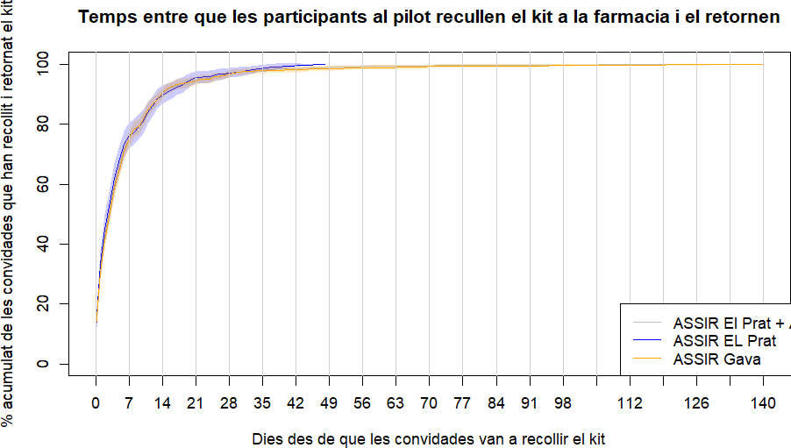

*Women who do not have a date of acceptance of participation in the pilot or return from the automobile show have been excluded.*

### Reasons for non-acceptance

A total of 105 (6%) convalescent women did not accept the self-sample and therefore did not participate in the pilot (16 at ASSIR El Prat and 89 at ASSIR Gavà). Their average age was 44 years (IQR: 35-51 years), with no statistically significant differences between the two ASSIRs participating in the pilot (*p-value=0.83*).

Figure 6 shows the reasons for refusing home sample collection with the self-sampling device. A total of 80 women (76%) reject the self-sample and prefer to have the sample collected by a health professional (8 at ASSIR El Prat and 72 at ASSIR Gavà). There are 7 women (7%) who have a request for an auto sample but have already been screened at ASSIR (2 at ASSIR El Prat and 5 at ASSIR Gavà). After 21 days of having been invited to the pilot, the women who had not yet gone to collect the autopsy were asked to remember the visit: 8 women (8%) were located and reminded of the visit (2 at ASSIR El Prat and 6 at ASSIR Gavà), and 10 women (10%) could not be located (4 at ASSIR El Prat and 6 at ASSIR Gavà).

**Figure 6. Reasons for non-acceptance of the autosample.**

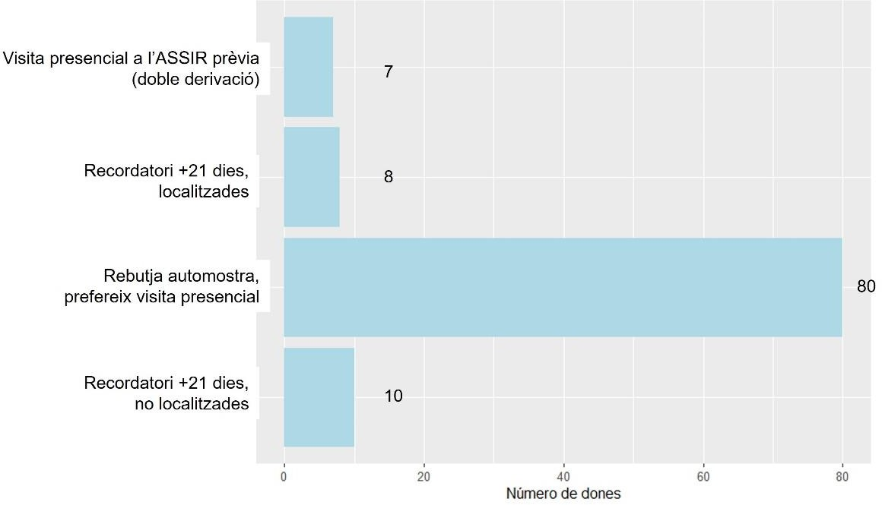

### Non-participation.

A total of 64 (4%) women convalescents accepted the autosample by collecting the material at the OF but did not return the sample and, therefore, did not participate in the pilot (13 at ASSIR El Prat and 51 at ASSIR Gavà). Their average age is 44 years (IQR: 37-51 years), with no statistically significant differences between the two ASSIRs participating in the pilot (44.6 years at ASSIR El Prat and 44.0 years at ASSIR Gavà; *p-value=0.82*). The average age of eligible women who participated in the pilot differs significantly from that of non-participants who collected the autosample but did not return it (47.4 years vs. 44.1 years respectively; *p-value=0.005*).

### Activity in the pharmaceutical distribution companies and distributors.

The distribution of the activity carried out in the different OFs participating in the pilot is shown in Figure 7. A total of 16 women collected more than 1 sample (2 samples in total): 9 women had a poor result with the first sample and went to collect a second sample to repeat the test, and 7 women had a problem with the first sample because they went to collect a second sample without returning the first one.

|  |
| --- |
| **Figure 7. Number of automostres collected and returned according to the Pharmacy Office.** |
| **7th ASSIR El Prat.** |
|  |

|  |
| --- |
| **7b. ASSIR Gavà.** |
|  |

The activity according to the pharmaceutical distributor is shown in Figure 8. In order to process the samples within the necessary period of 3 weeks from the date of the request, it is important that the sample does not take too long to arrive at the laboratory. For this reason, the follow-up process of the samples between the laboratory and the OTC is carried out daily by the OTC, with claims for samples not received within 2 weeks from the date of delivery to the laboratory. The OTC informs the Col-legi Oficial de Farmacèutics de Barcelona (COFB) by e-mail and from the COFB contacts the OFs and distributors involved in order to locate the samples.

**Figure 8. Number of samples delivered to the laboratory according to pharmaceutical distributor between 01/01/2023 and 30/06/2023.**

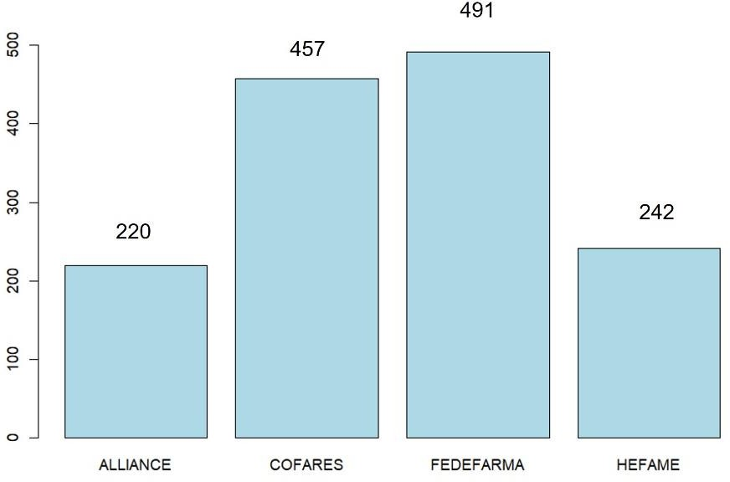

### Laboratory activity.

The time from sample delivery to the availability of the screening result is detailed in Figure 9.

The time elapsed between the return of the sample to the PO and its arrival at the ICO laboratory is 3 days, with a range between 1 and 38 days, depending on the pharmacy office and the pharmaceutical distributor. Within 7 days of sample delivery, 93% have arrived at the laboratory.

In order to be able to process the samples within the necessary period of 3 weeks from the date of the request, it is important that the sample does not take too long to arrive at the laboratory. For this reason, the follow-up process of the samples between the laboratory and the OTC is carried out daily by the OTC, with claims for samples not received within 2 weeks from the date of delivery to the laboratory. The OTC informs the Col-legi Oficial de Farmacèutics de Barcelona (COFB) by e-mail and from the COFB contacts the OFs and distributors involved in order to locate the samples.

The median time that elapses between the arrival of the samples at ICO and the generation of the result report is 4 days with a maximum time of 68 days. The 98% of the samples have had the report available 3 weeks after the arrival of the sample.

The time elapsed from the time the woman handed in the sample (date of the request for processing) until she was informed of the result was 7 median days, with a maximum time of 73 days. 96% of the women have been informed about the screening result at 21 days. There were 5 women with a screening result of more than 4 weeks and only one of them was processed outside the established time limit of 4 weeks from sample collection, as the delay was due to the delay in signing the report (38 days).

**Figure 9. Laboratory processes.**

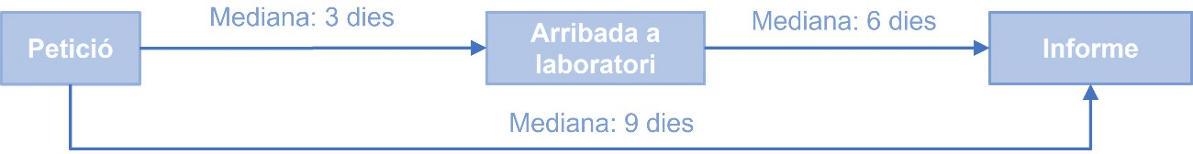

Medium: 3 dies

Medium: 4 dies

Median: 7 days

**HPV test results and follow-up.**

Among the 1,286 women with at least one sample processed in the laboratory between 01/01/2023 and 31/07/2023 (374 at ASSIR El Prat and 912 at ASSIR Gavà), 180 obtained a positive result for HPV (51 at ASSIR El Prat and 129 at ASSIR Gavà), which represents an overall positivity of 14% (13.6% at ASSIR El Prat and 14.1% at ASSIR Gavà) (Table 2).

The average age of the positive women was 44 years (IQR: 35-51 years), with no statistically significant differences between the participating ASSIRs (43.8 years in ASSIR El Prat and 44.1 years in ASSIR Gavà; *p-value=0.84*). The predominant result of the samples was a high risk HPV not 16 or 18 with 80.6% (N=145), followed by HPV16 with 15% (N=27) and HPV18 with 4.4% (N=8).

**Table 2. Results of the HPV detection test according to ASSIR.**

|  |  |  |  |
| --- | --- | --- | --- |
| **HPV screening with**  **automostra** | **ASSIR El Prat de Llobregat**  **N (%)** | **ASSIR Gavà**  **N (%)** | **Total**  **N (%)** |
| HPV negative | 323 (86,4%) | 782 (85,7%) | 1.105 (85,9%) |
| Positive HPV | 51 (13,6%) | 129 (14,1%) | 180 (14,0%) |
| HPV16 | 6 (11,8%) | 21 (16,3%) | 27 (15,0%) |
| HPV18 | 3 (5,9%) | 5 (3,9%) | 8 (4,4%) |
| HPV high risk no 16/18 | 42 (82,4%) | 103 (79,8%) | 145 (80,6%) |
| Poor quality | 0 | 1 | 1 |
| **Total** | **374** | **912** | **1.286** |

Among the women invited to the pilot in the period between 01/01/2023 and 30/06/2023 with a positive result, as of 14/09/2023 98% of the women had been visited and had undergone triage cytology (N=177). At the time of analysis, only one sample from ASSIR El Prat was pending the result. The results of the cytologies with available results are shown in Table 3 (N=176 samples). 60.2% of the cytologies performed in women with positive HPV test results were normal (54.2% in ASSIR El Prat and 62.5% in ASSIR Gavà), followed by 19.9% ASCUS (18.8% in ASSIR El Prat and 20.3% in ASSIR Gavà) and 9.7% LSIL (14.6% in ASSIR El Prat and 20.3% in ASSIR Gavà) and 9.7% LSIL (14.6% in ASSIR El Prat), followed by 9.9% ASCUS (18.8% in ASSIR El Prat and 20.3% in ASSIR Gavà) and 9.7% LSIL (14.6% in ASSIR Gavà).

ASSIR El Prat and 7.8% at ASSIR Gavà). A total of 4 cytologies were HSIL (1 at ASSIR El Prat and 3 at ASSIR Gavà) and 5 ASC-H (1 at ASSIR El Prat and 4 at ASSIR Gavà). Nine cytologies had an inflammatory result and are awaiting repeat cytology (4 at ASSIR El Prat and 5 at ASSIR Gavà).

**Table 3. Results of the triage cytology according to ASSIR.**

|  |  |  |  |
| --- | --- | --- | --- |
| **Triage cytology** | **ASSIR El Prat de Llobregat**  **N (%)** | **ASSIR Gavà**  **N (%)** | **Total**  **N (%)** |
| Normal | 26 (54,2%) | 80 (62,5%) | 106 (60,2%) |
| Inflammation | 4 (8,3%) | 5 (3,9%) | 9 (5,1%) |
| ASC-US | 9 (18,8%) | 26 (20,3%) | 35 (19,9%) |
| LSIL | 7 (14,6%) | 10 (7,8%) | 17 (9,7%) |
| HSIL | 1 (2,1%) | 3 (2,3%) | 4 (2,3%) |
| ASC-H | 1 (2,1%) | 4 (3,1%) | 5 (2,8%) |
| **Total** | **48 (100%)** | **128 (100%)** | **176 (100%)** |

The relationship between the HPV test result and the cytology result is shown in Table 4. Regarding the HPV16 positive women, at ASSIR El Prat two women have a normal cytology and two have an ASC-US, and one woman has an LSIL and the other has an inflammatory cytology pending to be repeated; on the other hand, at ASSIR Gavà, almost half of the women have normal cytology, and the rest are distributed, in order, in LSIL (N=4), ASC-H (N=3), HSIL (N=2) and ASC-US (N=1) and inflammatory (N=1). Regarding the HPV18 positive women, the woman from ASSIR El Prat has a normal cytology, and of the 5 women from ASSIR Gavà, 4 have a normal cytology and 1 has an ASC-US. If we look at the women positive for HPV no 16/18, about 60% of the women in the two ASSIRs have a normal cytology result. On the other hand, if we look at the ASC-US and LSIL cytologies, 17% of the women in the ASSIR El Prat have an ASC-US and almost 15% have an LSIL, while 23% of the women in the ASSIR Gavà have an ASC-US and only 6% have an LSIL.

**Relationship between the result of the primary HPV test with self-sample and the result of the triage cytology according to ASSIR.**

**4th ASSIR El Prat de Llobregat.**

|  |  |  |  |  |  |
| --- | --- | --- | --- | --- | --- |
| **Genotip HPV** | | | | | **Total N (%)** |
|  |  | **HPV16**  **N (%)** | **HPV18**  **N (%)** | **HPV no 1618**  **N (%)** |
|  | **Normal** | 2 (33,3%) | 1 (100%) | 23 (56,1%) | 26 (54,2%) |
| **Cytology results** | **Inflammation** | 1 (16,7%) | 0 (0%) | 3 (7,3%) | 4 (8,3%) |
| **ASC-US** | 2 (33,3%) | 0 (0%) | 7 (17,1%) | 9 (18,8%) |
| **LSIL** | 1 (16,7%) | 0 (0%) | 6 (14,6%) | 7 (14,6%) |
| **HSIL** | 0 (0%) | 0 (0%) | 1 (2,4%) | 1 (2,1%) |
|  | **ASC-H** | 0 (0%) | 0 (0%) | 1 (2,4%) | 1 (2,1%) |
| **Total per genotype HPV** | | **6 (100%)** | **1 (0%)** | **41 (100%)** | **48 (100%)** |

**4b. ASSIR Gavà.**

|  |  |  |  |  |  |
| --- | --- | --- | --- | --- | --- |
|  |  |  | **Genotip HPV** |  | **Total N (%)** |
|  |  | **HPV16**  **N (%)** | **HPV18**  **N (%)** | **HPV no 1618**  **N (%)** |
|  | **Normal** | 10 (47,6%) | 4 (80%) | 66 (64,7%) | 80 (62,5%) |
| **Cytology results** | **Inflammation** | 1 (4,8%) | 0 (0%) | 4 (3,9%) | 5 (3,9%) |
| **ASC-US** | 1 (4,8%) | 1 (20%) | 24 (23,5%) | 26 (20,3%) |
| **LSIL** | 4 (19,0%) | 0 (0%) | 6 (5,9%) | 10 (7,8%) |
| **HSIL** | 2 (9,5%) | 0 (0%) | 1 (1,0%) | 3 (2,3%) |
|  | **ASC-H** | 3 (14,3%) | 0 (0%) | 1 (1,0%) | 4 (3,1%) |
| **Total per genotype HPV** | | **21 (100%)** | **5 (100%)** | **102 (100%)** | **128 (100%)** |

# 3/ COORDINATION AND FOLLOW-UP ACTIVITIES WITH ALL THE AGENTS INVOLVED.

Since the beginning of the pilot program, monthly follow-up meetings have been held with all those involved at different levels (OTC-Catalan Oncology Institute, Oncology Director Plan, ASSIR, Bellvitge Hospital, Viladecans Hospital, CatSalut, COFB and CCFC) to evaluate the activity carried out and to plan improvement actions and the next steps to be taken.

At the OTC level, weekly individual follow-up meetings are held with all team members as well as bi-weekly internal meetings to coordinate the pilot and deployment of the new HPV protocol in Catalonia.

The OTC provides bimonthly updates in the form of a brief summary report to the laboratory and the COFB, which is subsequently distributed to the pharmacies participating in the pilot. These reports contain the activity data, as well as the preliminary results of new actions that are implemented.

## Annexes

### Annex 1. Pharmacies participating in the pilot. LIST OF PHARMACIES ADHERED TO THE PROGRAM

|  |  |  |  |  |
| --- | --- | --- | --- | --- |
| **POPULATION** | **NOM** | **ADREÇA** | **C.P.** | **TELEPHONE** |
| BEGUES | BORRAS URTUBIA, T. | SANT EUDALD 83 | 08859 | 936240872 |
| BEGUES | TORNERO BERGOS, SONIA | MAJOR 37 | 08859 | 936390586 |
| BOTIGUES, LES | JORBA JULIA, ROSA | LES BOTIGUES DE SITGES 6 Av. | 08860 | 936644909 |
| CASTELLDEFELS | ALBALA HURTADO, SOLEDAD | Rda. RAMON OTERO PEDRAYO (FARMÀCIA) 32 | 08860 | 936361059 |
| CASTELLDEFELS | ARGELAGA VALLS, ANA MA. | ARCADI BALAGUER 64 | 08860 | 935390129 |
| CASTELLDEFELS | CHACON PUIG, ROBERTO | DIAGONAL Av. 30 | 08860 | 936652318 |
| CASTELLDEFELS | GALCERA PIÑOL, MONICA | Pg. MARÍTIM 249-2 | 08860 | 936657409 |
| CASTELLDEFELS | GARCIA LOPEZ, BERTOMEU / CORRES ORUE, JUAN JOSE | ARCADI BALAGUER 17 | 08860 | 931069853 |
| CASTELLDEFELS | GORDO BORT, JOAN CARLES | Av. MAR 2 | 08860 | 936651893 |
| CASTELLDEFELS | GORINA TORRENTS, A | ARCADI BALAGUER 67 | 08860 | 936650894 |
| CASTELLDEFELS | GRILLO DORCA, JOAN | PAINTER SERRA SANTA 17 | 08860 | 936360416 |
| CASTELLDEFELS | ITARTE CASANOVA, MA.DOLORS / BELENCOSO YTARTE, CAROLINA | PINEDA Av. 20 | 08860 | 936654811 |
| CASTELLDEFELS | LLORENS BERNAT, TERESA | AGUSTINA DE ARAGÓN 87 | 08860 | 936652694 |
| CASTELLDEFELS | MARTINEZ CORBACHO, PABLO | VIRIATO 2 | 08860 | 936651138 |
| CASTELLDEFELS | MONTAÑANA-PALOMO | 390 CONSTITUCIÓ Av. | 08860 | 936650083 |
| CASTELLDEFELS | SANCHO CEJAS, MA.JOSE | 206 CONSTITUCIO Av. | 08860 | 938348791 |
| GAVA | ESCOLANO TRUCO, VICTOR | BEGUES 6 | 08850 | 936380866 |
| GAVA | ESPINA MATEOS, CARLOS | POMPEU FABRA 180 | 08850 | 935414803 |
| GAVA | FAIMAN SZULC, CLAUDIA PATRICIA | COLOMERES 60 | 08850 | 936334477 |
| GAVA | GARCIA-VELA GRAU, FRANCISCO | GAUDI 4 | 08850 | 936621835 |
| GAVA | ALGUERÓ, INÉS | Crta. STA.CREU DE CALAFELL 135 | 08850 | 936623712 |
| GAVA | LAUROBA CANALETA, CAROLINA | AUT.CASTELLDEFELS-KM.16.530 | 08850 | 936332133 |
| GAVA | LOPEZ PAZ, SYLVIA | Av. DE L'ERAMPRUNYA 17 | 08850 | 936621799 |
| GAVA | LOPEZ RODRIGUEZ, J.L. | Rbla. POMPEU FABRA 142 | 08850 | 936621232 |
| GAVA | MUÑOZ MENDEZ, DANIEL | Rbla. VAYREDA 24 | 08850 | 936620388 |
| GAVA | PAZ DONOSO, CARMEN | SAINT TERESA 60 | 08850 | 936622646 |
| GAVA | PUGES CRISOL, MA.CARMEN | Pg. JOAN MARAGALL 23 | 08850 | 936623113 |
| GAVA | PUIGDEVALL VALERO, MIQUEL A. | JOAN CARLES I 56 | 08850 | 936381979 |
| GAVA | RIVERO MORENO, BEATRIZ | DIAGONAL 7 | 08850 | 936384055 |
| GAVA | SANCHEZ MORATOS, JOSEFA | SALVADOR LLUCH 20 | 08850 | 936389599 |
| GAVA | TORNE FELIP, MERCE | SANT LLUIS 54 | 08850 | 936318764 |
| PRAT DE LLOBREGAT, EL | PORTILLO FABRO, ANNA | ENRIC BORRAS 35 | 08820 | 933794044 |
| PRAT DE LLOBREGAT, EL | ALVAREZ - QUINTANA | MAJOR 12 | 08820 | 933790601 |
| PRAT DE LLOBREGAT, EL | SERRABOU, BELEN | LLEIDA 88 | 08820 | 933794675 |
| PRAT DE LLOBREGAT, EL | HERRERA GUILLEN, ESTHER | URGELL 60-64 | 08820 | 933794389 |

|  |  |  |  |  |
| --- | --- | --- | --- | --- |
| PRAT DE LLOBREGAT, EL | MARIN PARES, E. | MAURICI VILOMARA 48 | 08820 | 933792200 |
| PRAT DE LLOBREGAT, EL | MILA PRÜNTE, EVA | VERGE DE MONTSERRAT 45 Av. | 08820 | 933791230 |
| PRAT DE LLOBREGAT, EL | CASAS PLA, JAUME | DE LA MARINA 7 | 08820 | 933790996 |
| PRAT DE LLOBREGAT, EL | CASAS SANCHEZ, JORDI | ONZE DE SETEMBRE 185 | 08820 | 934787311 |
| PRAT DE LLOBREGAT, EL | CASTLE-EL OUMRI | VERGE DE MONTSERRAT 135 Av. | 08820 | 933791418 |
| PRAT DE LLOBREGAT, EL | GUERRERO DUEÑAS, J.A. | CENTRE 15 | 08820 | 933703802 |
| PRAT DE LLOBREGAT, EL | BOSCH GRANE, MARTA | FREDERIC SOLER 76 | 08820 | 933794807 |
| PRAT DE LLOBREGAT, EL | FABRO YAGUE, MERCÈ | FERRAN PUIG 8 | 08820 | 933790122 |
| PRAT DE LLOBREGAT, EL | LLULL FERRO, MARTA | PALAMOS 6 | 08820 | 933794756 |
| PRAT DE LLOBREGAT, EL | SERRAMIA BRUXOLA, M | VERGE DE MONTSERRAT 257-2 Av. | 08820 | 933795292 |
| PRAT DE LLOBREGAT, EL | PIMENTEL GODOY. M. ELENA | RIU EBRE 19 | 08820 | 933793945 |
| PRAT DE LLOBREGAT, EL | MOLA - GELADA | RIU LLOBREGAT 68 | 08820 | 933791455 |
| PRAT DE LLOBREGAT, EL | CATALAN, N | ESTANY DE LA MURTRA 1 | 08820 | 933795493 |
| PRAT DE LLOBREGAT, EL | FALCO FERRER, N | FREDERIC SOLER 34 | 08820 | 933791505 |
| PRAT DE LLOBREGAT, EL | MORANCHO ECHEVERRIA, OLGA | MONTSANT 18 | 08820 | 933798721 |
| PRAT DE LLOBREGAT, EL | SANCHEZ CALUCHO, ROSA | Crta. DE LA MARINA 112 | 08820 | 933793481 |
| PRAT DE LLOBREGAT, EL | MILA PRÜNTE, VICTOR | ROSA RIBAS I PARELLADA 23 | 08820 | 933791096 |
| PRAT DE LLOBREGAT, EL | VENTOSA BARRÓN, Z | PRIORAT s/n | 08820 | 933797522 |
| SANT CLIMENT DE LLOBR. | MOLTO RODRÍGUEZ, FERNANDO | Pl. LLUÍS COMPANYS 6 | 08849 | 936581491 |
| VILADECANS | ARRIBAS ADRIAN, JORGE | SEGLE XXI (CENTER COMERCIAL) | 08840 | 935413499 |
| VILADECANS | BADIA DEL ROMERO, JUAN CARLOS | PERE SALA 60 | 08840 | 936582642 |
| VILADECANS | BADIA DEL ROMERO, STELLA | DEL LLEVAT 2 B | 08840 | 936817238 |
| VILADECANS | BALTASAR BORRELL, ANTONIETA | GUIFRÉ EL PILÓS 36 | 08840 | 936377175 |
| VILADECANS | BERGA CULLERE, CAROLINA | SANT CLIMENT 58 | 08840 | 935665065 |
| VILADECANS | BERGA I MARTI, CARLOS | JAUME APRIL 23 | 08840 | 936582598 |
| VILADECANS | BRESCO MANCHO, JOSE MANUEL | SOL 67 | 08840 | 936580895 |
| VILADECANS | IBAÑEZ FERNANDEZ, JOSE | Av. GENERALITAT 28 | 08840 | 936580444 |
| VILADECANS | GARRIDO ZAFRA, MONTSERRAT | CANONGE DR. AUGUET 82 | 08840 | 936470080 |
| VILADECANS | MARTÍNEZ CODINA, MARC | Pl. ARQUEBISBE MODREGO 11 | 08840 | 936581685 |
| VILADECANS | MONTES CORRALES, MANUEL | MIL-LENARI 6 | 08840 | 933879289 |
| VILADECANS | NICOLAS SOLER, Mª CRISTINA | PRAT DE LA RIBA 66 | 08840 | 936581184 |
| VILADECANS | NIUBO ESLAVA, ITZIAR | GAVA Av. 13 | 08840 | 936581837 |
| VILADECANS | ROCABEYERA RUIZ, MARGARITA | LLUÍS COMPANYS 1-3 | 08840 | 936594665 |
| VILADECANS | SALA CARCEL, NATIVIDAD/ GARCIA  SALA, XAVIER/ GARCIA SALA, DANIEL | SANT MARIANO 99 | 08840 | 936580048 |
| VILADECANS | URIARTE CULLERÉ, MIGUEL | DR. REIG, 67 | 08840 | 936473101 |
| VILADECANS | URIZ FINA, MERCEDES | MIRAMAR Av. 7 | 08840 | 936472198 |
| VILADECANS | VILA BADIA, FRANCESC | Av. DEL MOLÍ 37 | 08840 | 936376900 |